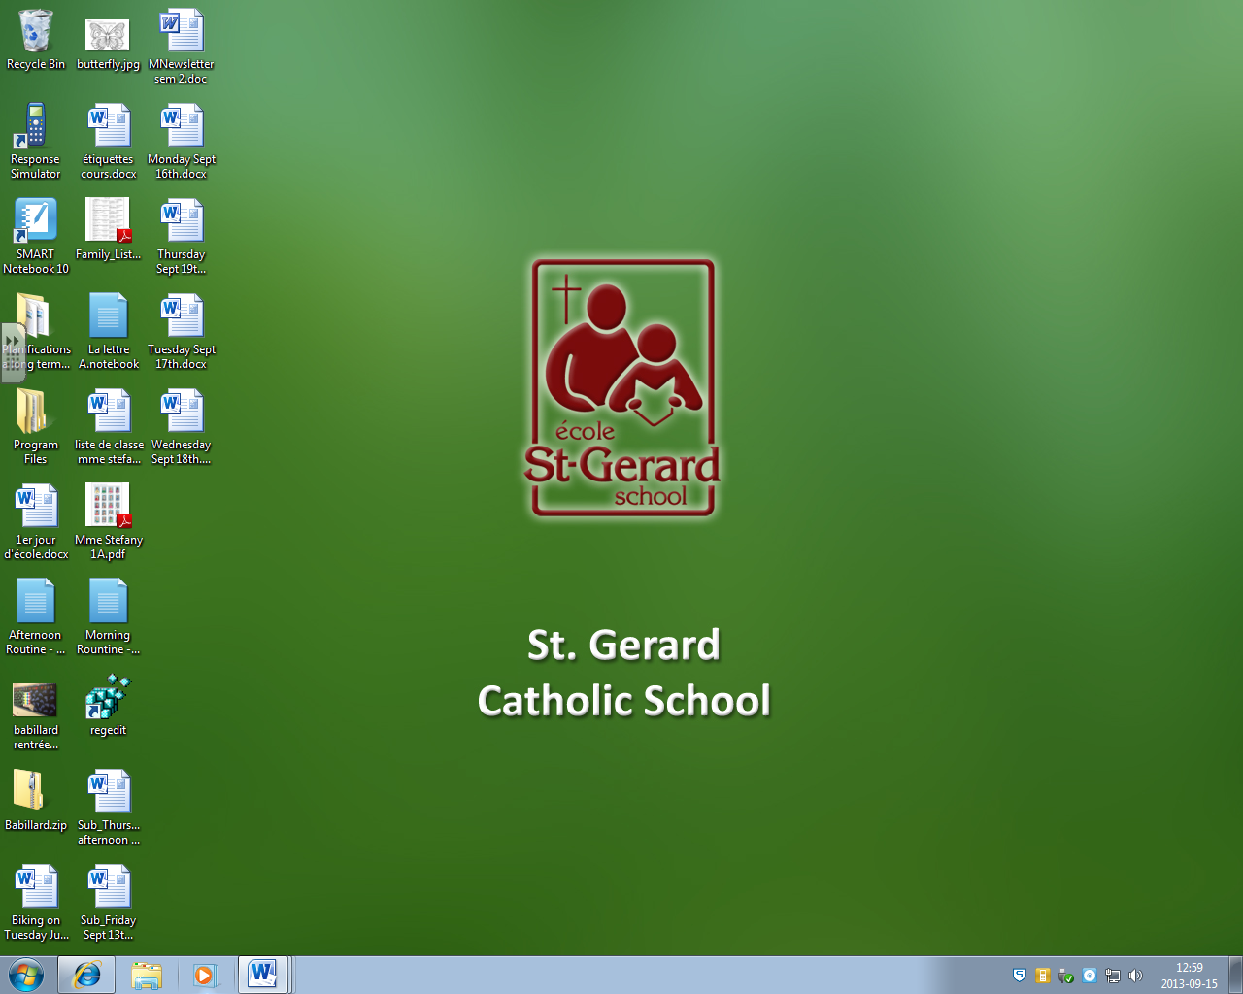How to open my Smart Board routines

Double click on the file icon

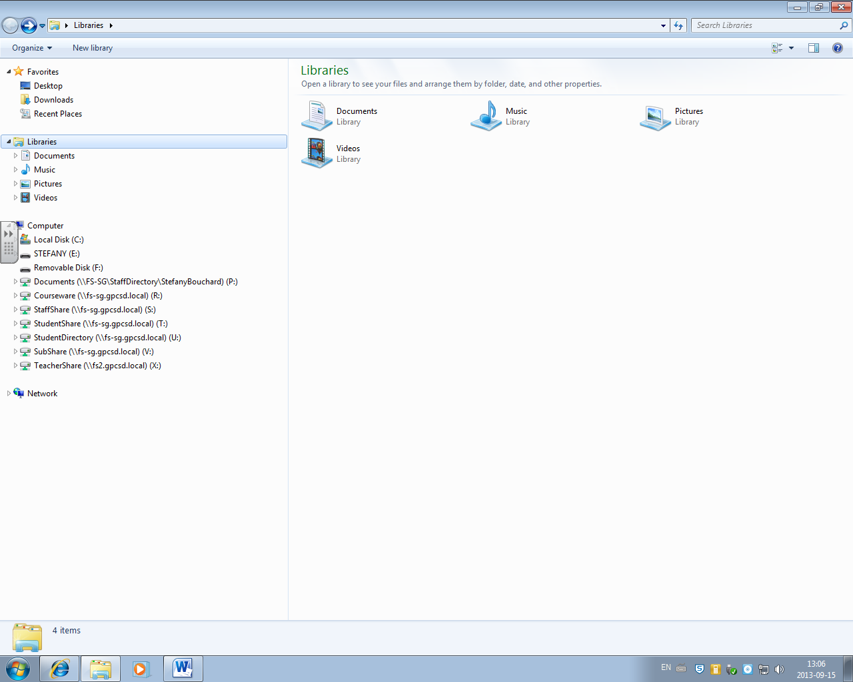

One click on Removable Disk (F)

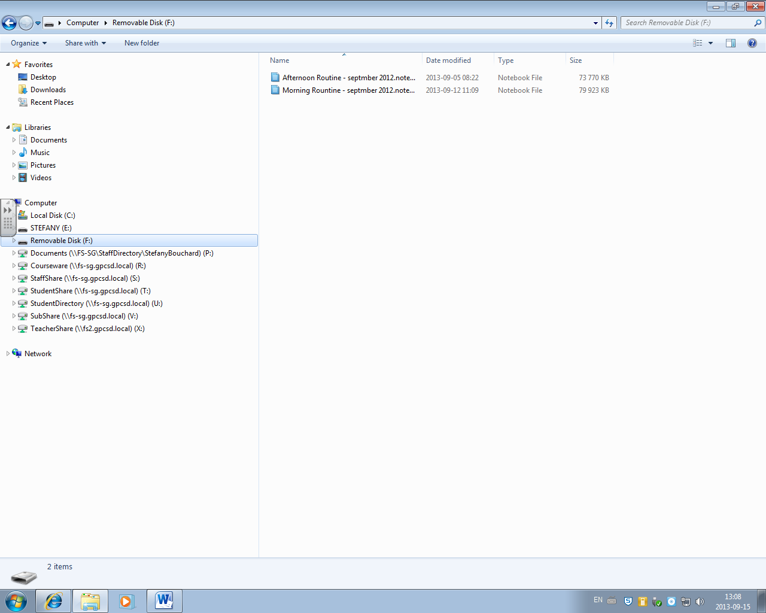

Double click on either morning or afternoon routine